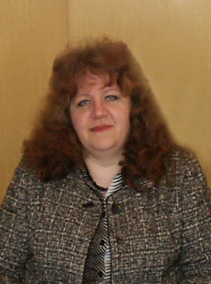
Bazina M. А.
In 1988 she graduated from cartographical faculty of MIIGAandC. Worked as a cartographer and the chief of cartographical shop. Since 1993 works as the assistant of the main engineer in Verkhnevolzhskiy aerogeodetic enterprise.

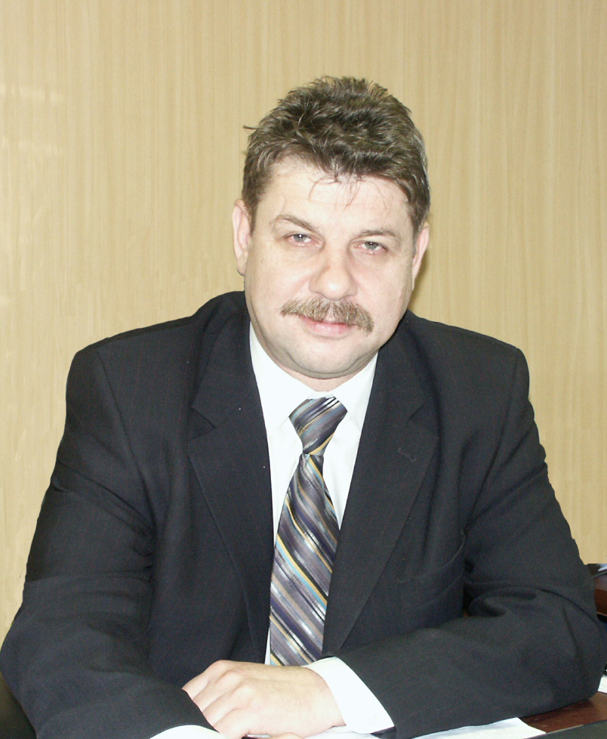
Yerukov S.V.
In 1980 finished the Moscow topographical polytechnical school.
Worked as a technician, the chief of the party, the chief of expedition, the main engineer of the enterprise (Nizhni Novgorod). In 2002г. graduated from Volgo - Vyatskiy academy of civil service. Since December 2006г. - general director FGUP"VAGP".
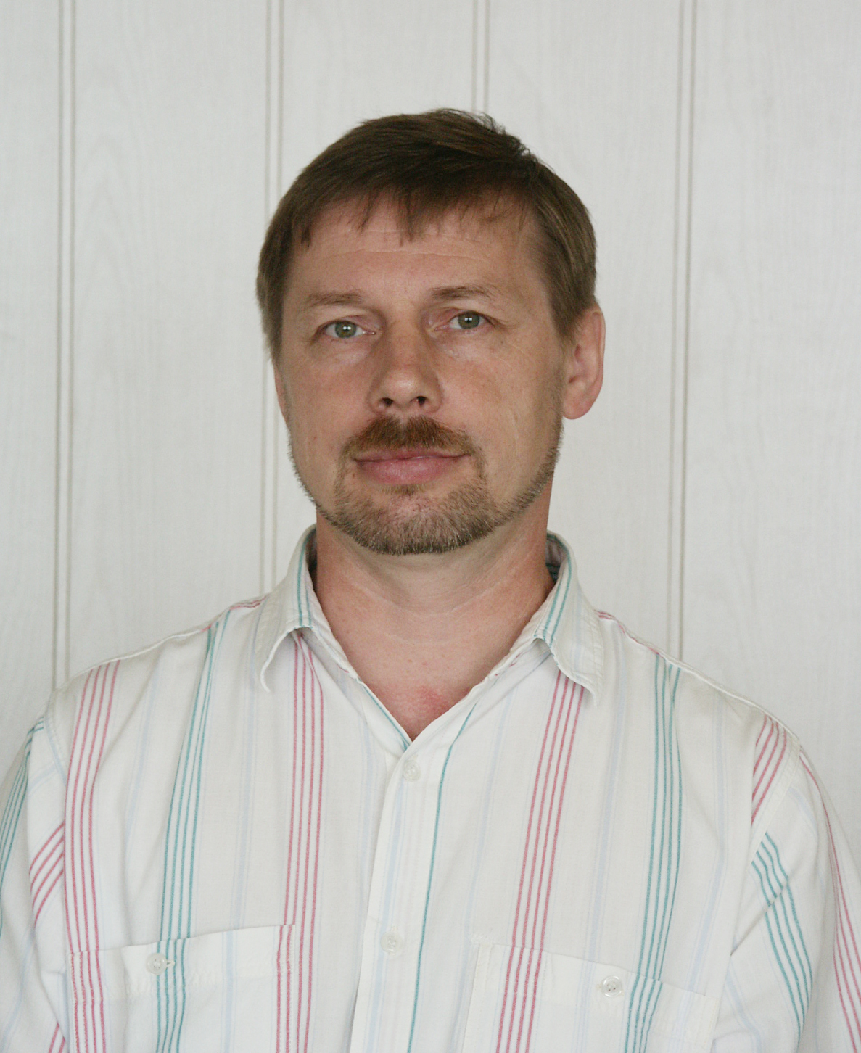
Myasnikov A.L.
In 1991 graduated from the faculty of designing and radio equipment manufacture of Gorkiy polytechnical institute. Worked as a programmer. Since 1995 works in Verkhnevolzhskiy aerogeodetic enterprise as a leading expert in information systems.

METHODS OF MODELING CONVENTIONAL DESIGNATIONS AND VARIOUS DISTRICT MODELS IN ORDER TO IMPROVE VISUAL PERCEPTION OF CARTOGRAPHICAL DISPLAY
Bazina M.A., Yerukov S.V., Myasnikov A.L
The federal state unitary enterprise
"Verkhnevolzhskiy aerogeodetic enterprise"
E-mail: vagp@mts-nn.ru
Nowadays rapid development of computer technologies, hard- and software allows to speak about a new approach to their use in cartography.
Peculiar interest arouses the development of the technologies of visualization of the information based on hard- and software means of work with three-dimensional graphics.
The use of three-dimensional visualization of the information in cartography, opens new opportunities for all spheres of activity.
It is known, that any map and any image of geographical objects is a model - a constructed image of real objects and situations (space) that may be estimated, operated with or used to fulfill different tasks and make decisions.
A model of spatial data is a way of digital description of spatial objects. The most widespread structure types of the spatial data are the following:
- Vector representation (vector-topological representation, vector-non-topological representation);
- Raster representation;
- Regular - cellular representation;
- Quadrotree;
- Hiporgraphic representation;
- TIN-models.
Cartographical production or electronic maps have three basic forms of representation:
1) Representation of geographical objects in a vector form;
2) Representation of geographical objects in a raster form;
3) Representation of geographical objects in a universal form (synthesis of vector and raster forms and spatial metadata form).
Visualization or graphic reproduction (display) of models of spatial data is designing and generating the image displaying it (mainly on a screen) with the help of initial digital data, rules and algorithms of their transformation.
The images, received during visualization, can be:
- Flat or two-dimensional;
- Volumetric or three-dimensional;
- Dynamic (three or four-dimensional)
Besides there exist a large variety of combined geoimages.In any case a cartographical geoimage should contain:
- Geographical objects expressed by means of conventional designations;
- Surface or relief expressed by district models.
Choosing a kind and form of displaying conventional designations and district models on an electronic map, the operator, depending on the function of the map, models or forms thus the image, that in its turn can be used to achieve the necessary objectives, in order to draw attention or select the most important properties of the visual information out.
Symbols or designations modeling
Modeling visual display of symbols on electronic maps consists in change
in their properties without change in their logic - semantic loading. The authors of the report having analyzed visual properties of cartographical symbols, considering the rules (principles) of construction of cartographical designations which conform graphic images with the semantic contents of a displayed object, observing principles of semantic coding, came to a conclusion, that a change in basic visual properties of conventional signs, which determine correct and unequivocal recognition and mental decoding, is inadmissible.
Hence when selecting and allocating objects on an electronic map it is necessary to use colour change of frontier area of designations, as a change in colour of an environmental background is a bright alarm indicator.

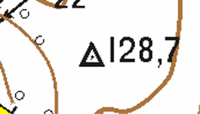 I)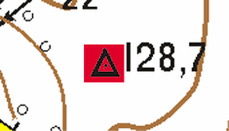 II) 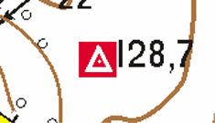

Fig. 1.
I) Fragment of a map before allocation of an out of scale sign
II)Fragment of a map after allocation of an out of scale sign
Inversion of the colour of object can also be applied here(fig. 1).
For square conventional signs the change in the intensity of a background fillup colour can be used as an attribute of allocation.
The most perspective type of allocation of objects and whole areas of geoimage is the use of animation methods.
Most widely used methods:
- "blinking" of marks, both with and without change in their size.
- colouring variations(pulsation and defillation),change of intensity, creation of colour vibration effect.
To single out separate areas of the geoimage there can be used:
- a change of light exposure or background, "brightening" or "shadowing";
- anamorphotic "Lens" effect (round and rectangular)
Modeling of district models
In GIS and digital cartography there can be three kinds of representation of district models both as a relief and surface.
  - Modeling a surface with the help of vector data.
The vector data represent spatial objects as points, lines and ranges and is the best in depicting discrete objects with certain forms and borders.
  - Modeling with the help of rasters. Raster data are continuous data or images. Each cell (or pixel) in a raster characterize the analyzed object.The most typical data source is a space image or aerophotographs.
  - Modeling with the help of triangulation (TIN)
TIN is a useful and effective way of fixation of a ground site surface. TIN supports perspective images. Atop TIN it is possible to impose the photographic images for photorealistic display of a district relief.TIN also makes possible the creation of various kinds and forms of district model visualization.
Variety of kinds of modeled conventional designnations and district models can possibly be used in electronic maps not depending on their function. The choice is to be made by a person himself.
In Verkhnevolzhskiy aerogeodetic enterprise a breadboard model of the program " Visualization of a relief " was made.
A general description of a breadboard model of the program " Visualization of a relief "
The developed program "Relief" allows to make a matrix of a relief on the basis of a file with X, Y, Z coordinates, imposing surface raster (fig. 2). 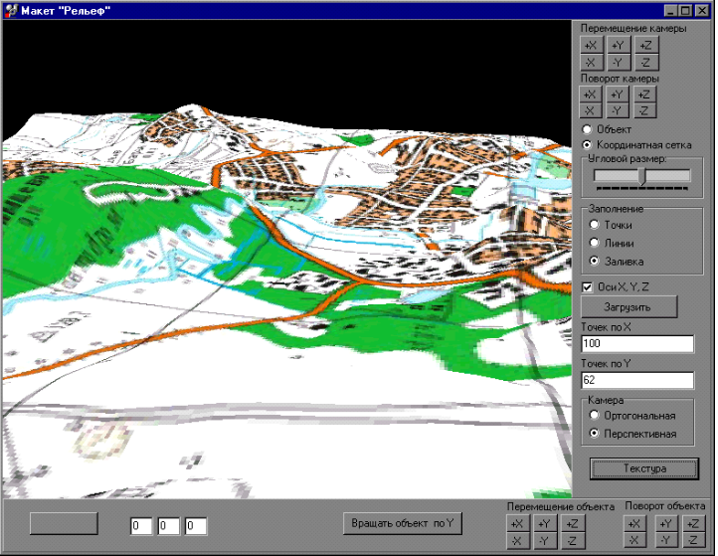
Fig. 2

The final three-dimensional stage can be represented as continuous texture (fig. 2), triangles (skeleton) (fig. 3), or top points of triangles (fig. 4).
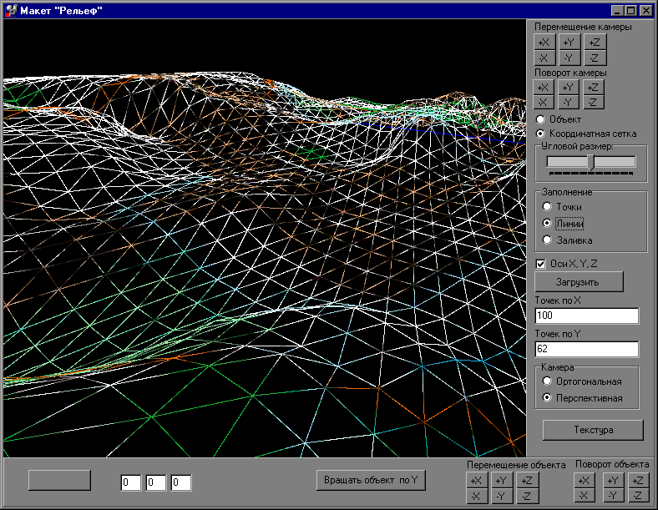
Fig. 3
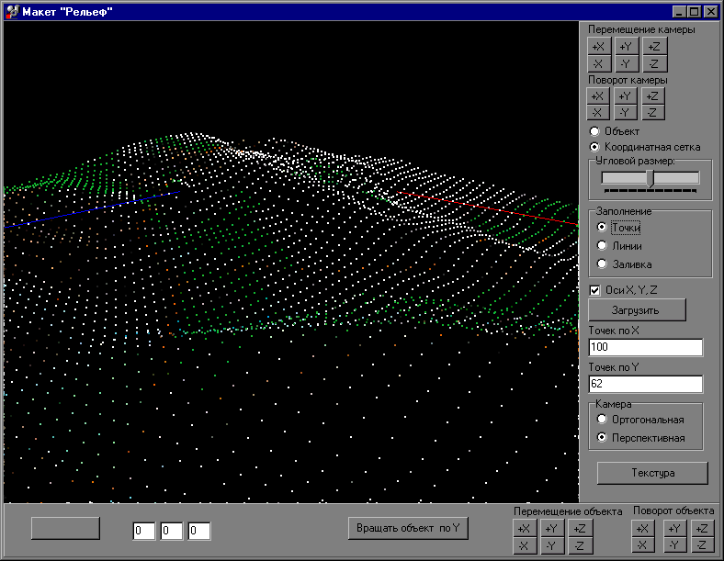
Fig. 4
The navigation occurs with the help of a "Mouse" manipulator, thus it is possible to choose whether to operate camera view of the object or the object itself. Thus viewing of a relief can be made both from above, and from below.
The work speed of the program is influenced by the following factors: a kind of a description (unilateral or bilateral, continuous fillup, skeleton or points), presence of 3d videomap accelerator and amount of matrix object points.
The presented survey was made with Pentium III 1800, 512 Mb of the RAM, videomap NVIDIA Riva TNT 2.
There was used matrix 100х62 points (~ 12.5 thousand triangles), texture 800х600 points in BMP format (~ 1Мb).Though the work speed was sufficient.
The general testing of serviceability has shown the low system requirements to productivity of the computer (considering modern computers (Pentium II and higher, with the videoaccelerator).
During creation of the given breadboard model the following tasks were solved:
- Dynamic display of a relief, with cartographical information as texture;
- Creation a three dimensional matrix of height on the basis of two dimensional colour model;
- Optimization of work speed (testing has shown serviceability of the program on Pentium 166, 48 Mb of the RAM, videomap without the accelerator).
It is necessary to note, that the realized model of relief visualization with the use of a map as texture is evident enough, all conventional designations are well read. But to enrich presentation it is necessary to use additional three dimensional conventional designations and three dimensional elements of the text.
The display of three dimensional conventional signs should be dynamically operated, and used only to stress attention out, as the speed of display of any of three dimensional stage depends on the amount of objects on this stage.
The development of three dimensional conventional designations is serious work, as it should solve contradictory tasks:
- Presentation (the conventional sign should unequivocally characterize the displayed object);
- Simplicity (sides of triangles object should be brought to a minimum);
- Readability in space (the conventional sign should unequivocally be read from any point).
The literature
1 Bazina M.A., Pulyayevskiy V.A., Timkina O.V. New technologies of electronic maps visualization. The theses of the reports of the International congress "Great rivers 2005". Volume 1, P. 323-324
2 Gusein-Zade S. М., Tikunov V. S. Anamorphoses: what is it? - M.: Editorial URSS, 1999. P. 168.
3 Pobedinskiy. G.G., Martynenko A.I., Bazina M.A. A problem of optimal visualization of electronic maps, Works of the International Forum about science, engineering and education problems. Volume 2. - M.: The academy of sciences about the Earth, 2000, P. 128-129.
4 Pobedinskiy. G.G., Bazina M.A., Vturin A. V. System engineering of electronic maps visualization. Geodesy and cartography, 2002, 3, P. 25-30
5 Tikunov V. S. Modeling in cartography. - M.: Publishing House of MSU, 1997. P.405

